Creación de controladores para las tablas:

Curso:

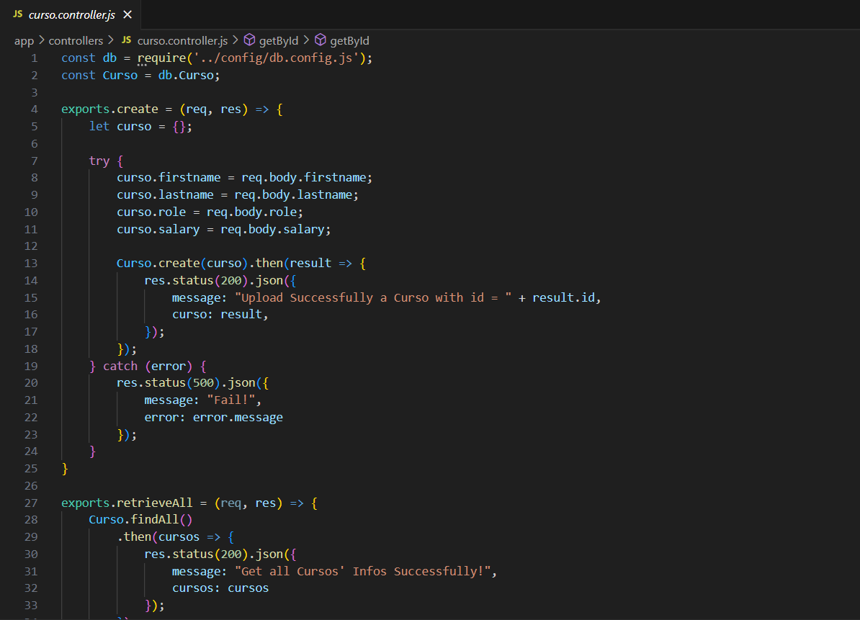

Estudiante:  
  
Uso de api:  
  
Aplicación en Apex:

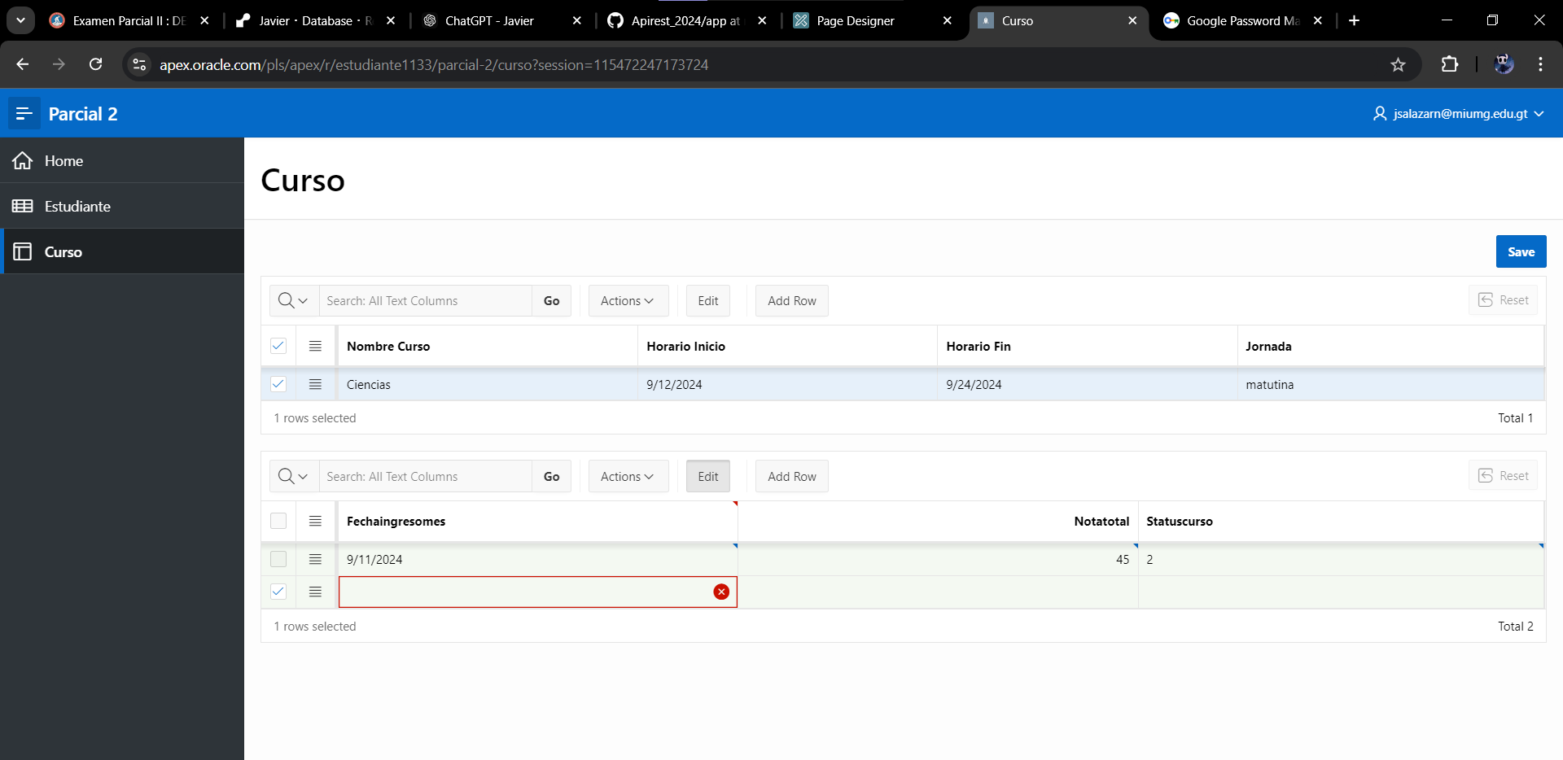

Contraseña y usuario:  
  
[Jsalazarn@miumg.edu.gt](mailto:Jsalazarn@miumg.edu.gt)

mantecA16.

Workspace: estudiante1133